Azure Data Factory Incremental Ingestion Pipeline

Introduction
The Project Implements an incremental batch ingestion pipeline using Azure Data Factory (ADF) to move shipment data from Azure Data Lake Storage (ADLS - Raw layer) to bronze layer, while maintaining a watermark-based control mechanism to ensure:
- No duplicate ingestion
- Controlled incremental loads
- Recoverability
- Auditability
Pipeline is Fully Automated, parameterises and monitored, with alerting enabled for successful runs.

1. Source Data Structure
raw/
└── shipments/
└── shipment_daily_YYYY-MM-DD.csv
Each batch represent data for specific ingestion date

2. Watermark Design
Purpose:
The watermark tracks the last successfully processed date and operational metadata required for incremental ingestion
Watermark File (JSON)
Stored in ADLS
control/shipments_watermark.json

Watermark Structure
{
"entity":"shipments",
"last_successfull_date":"2023-01-22",
"last_update_ts":"2026-0210T06:57:42.2073290Z",
"rows_added":821237,
"files_added":1
}

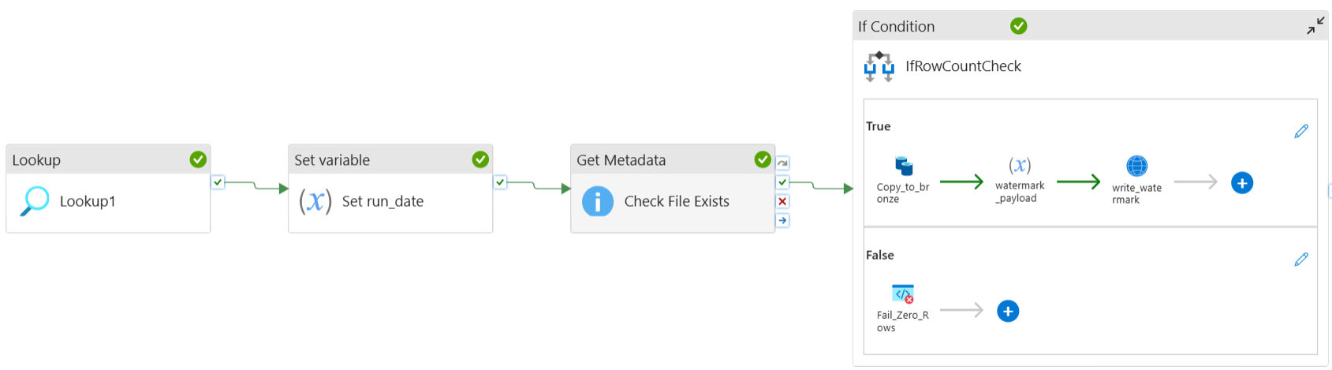
3. Pipeline Architecture Overview

Pipeline Flow
- Lookup Activity: Read watermark using lookup activity
- Set variable (run_date): Calculate the next run Rate
- Get Metadata: Check if the Expected source file exists
- Copy Data: Copy data from Raw to Bronze layer
- If Condition: Check the Row Counts condition
  - Truth: If Row exists
    - Copy Data: Data Movement from raw to bronze
    - Set Variable (watermark_payload): Update the watermark variable
    - Web Activity: Update the watermark control file

4. Activity Level Explanation
- Pipeline Variable Initialisation: Declaring variables in the pipeline canvas to access and modify the variables throughput the pipeline execution.
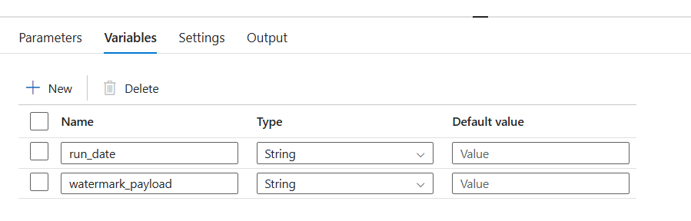
- Lookup Activity: Reads the last successful ingestion date from the watermark file.
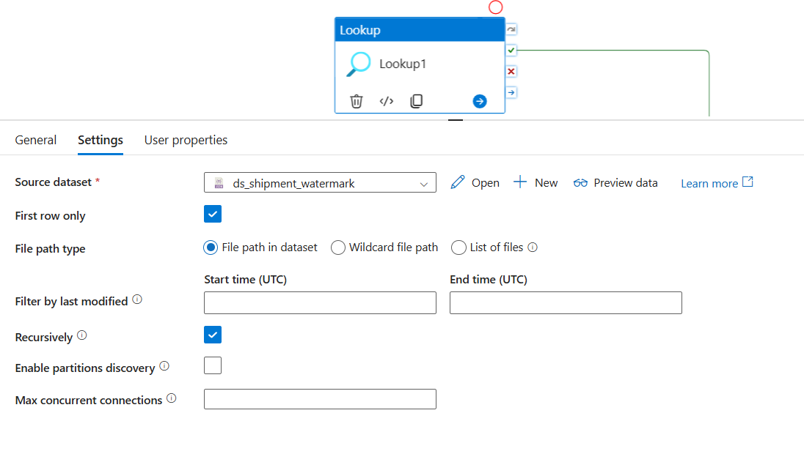
- Set Variable (run_date): Computes the next ingestion date based on the watermark value.
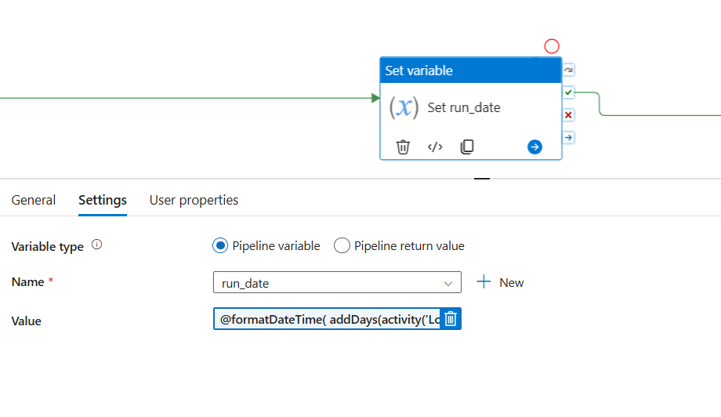
- Get Metadata: Validates whether the expected daily file exists before ingestion.
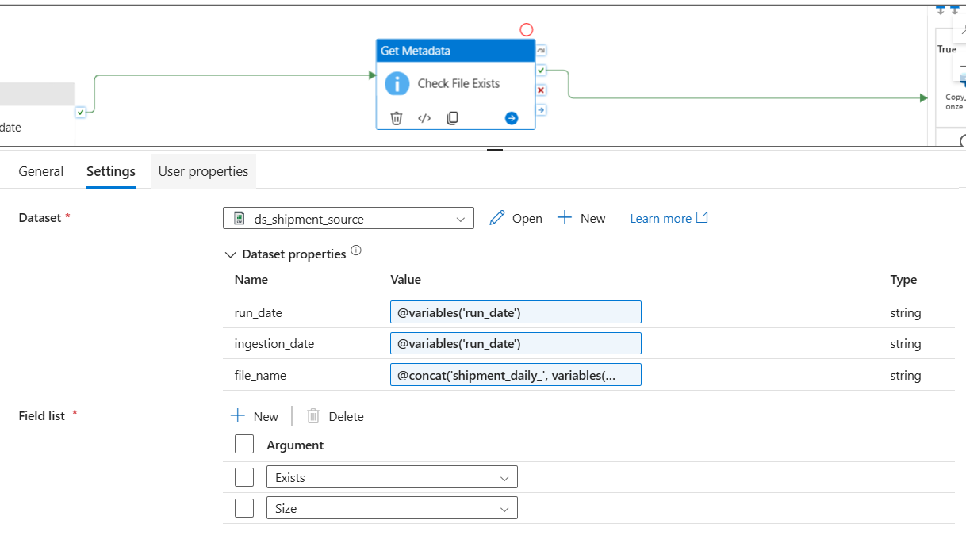
- If Condition: Ensures data is copied only when the source file exists.
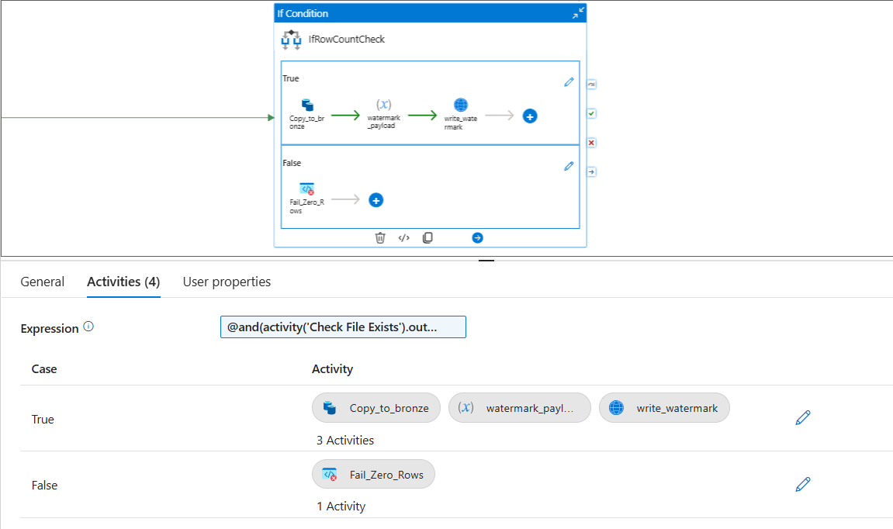
- Copy Activity: Moves shipment data from Raw storage to the Bronze layer.
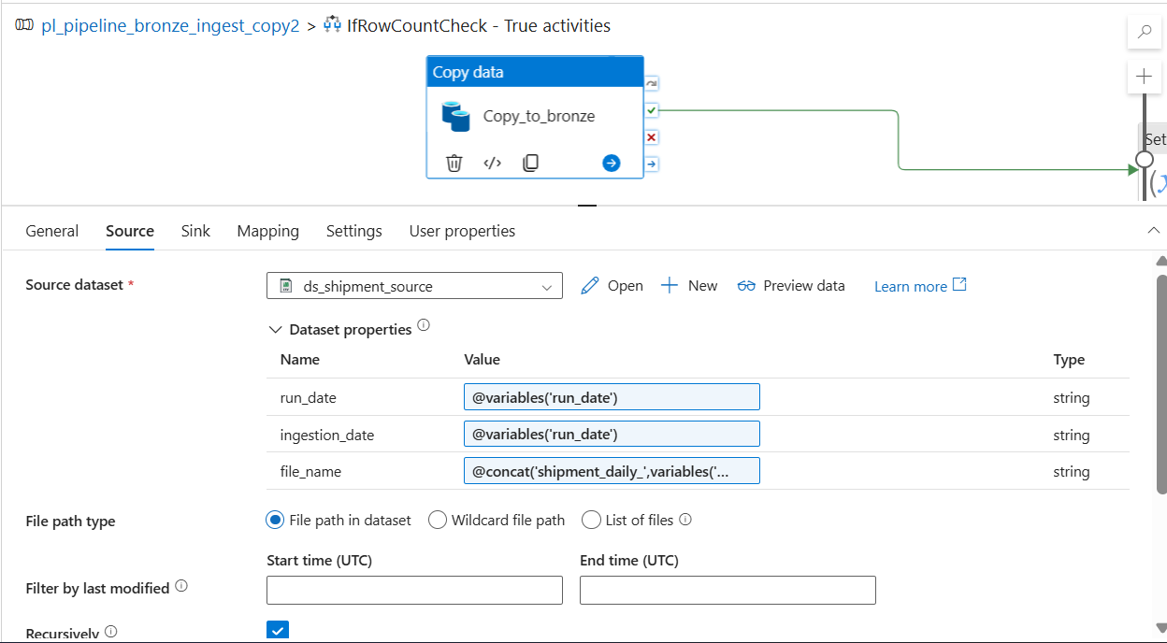
- Set Variable (watermark_payload): Constructs a JSON payload containing updated watermark values.

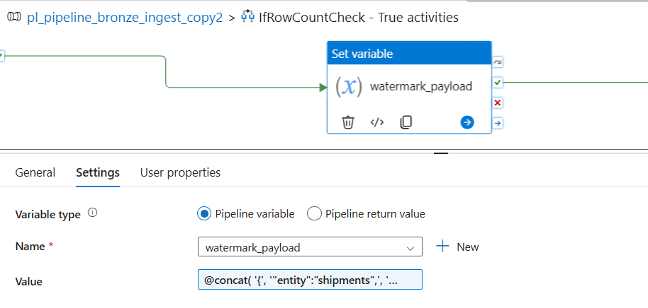
- Web Activity: Overwrites the watermark JSON file using an HTTP PUT operation.
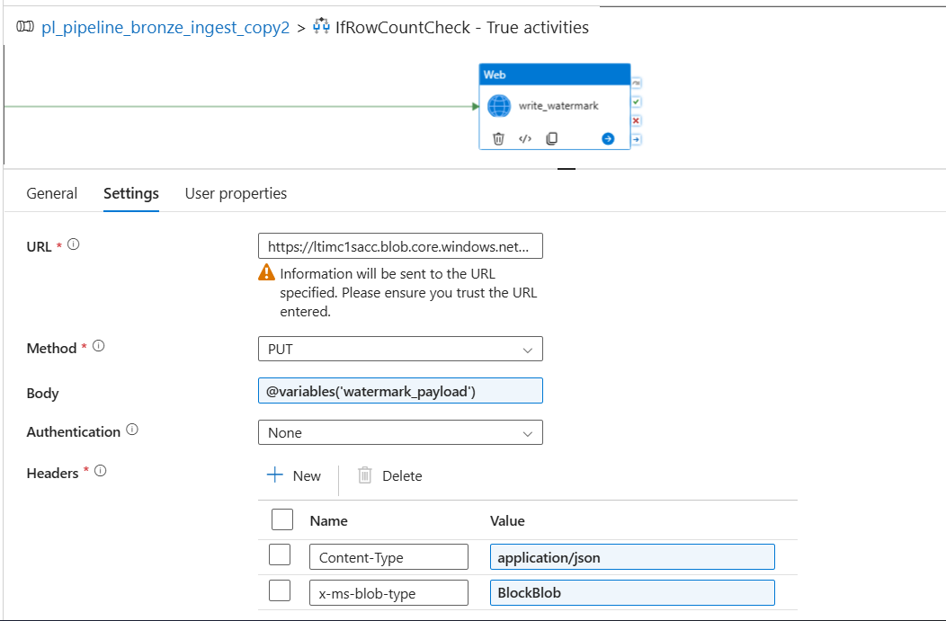

5. Trigger Automation
The pipeline is automated using an Azure Data Factory Schedule Trigger configured to run once per 3 minutes (Ideally once per day). No pipeline parameters are required, as the watermark controls incremental execution.
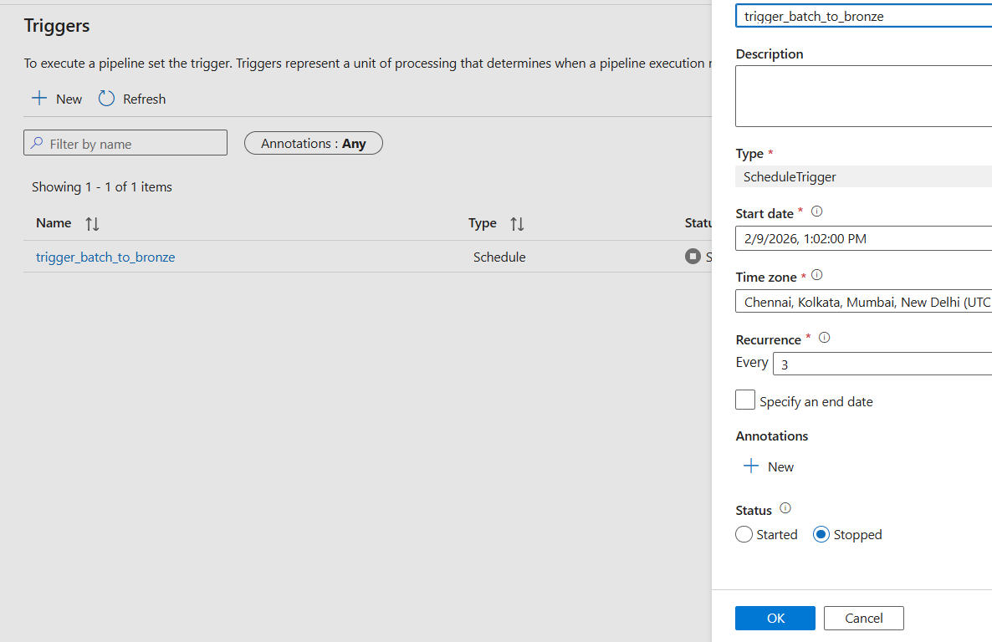
Overwrites the watermark JSON file using an HTTP PUT operation.

6. Error Faced and Resolutions
Duplicate Column Errors
Caused by using Copy Activity to update JSON.

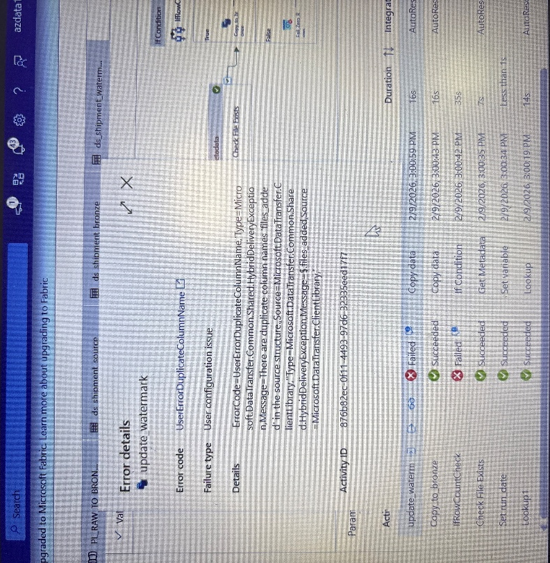
Resolved by switching to Web Activity with full overwrite.
Authentication Failures
Managed Identity is not supported for Blob PUT operations.
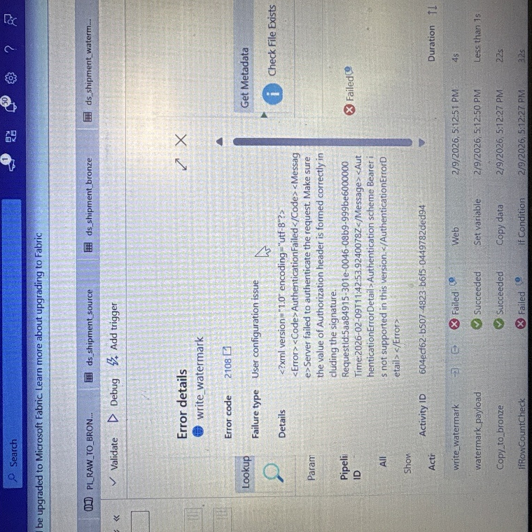
Resolved by using SAS token authentication.

DFS Endpoint Errors
Web Activity does not support DFS endpoints.
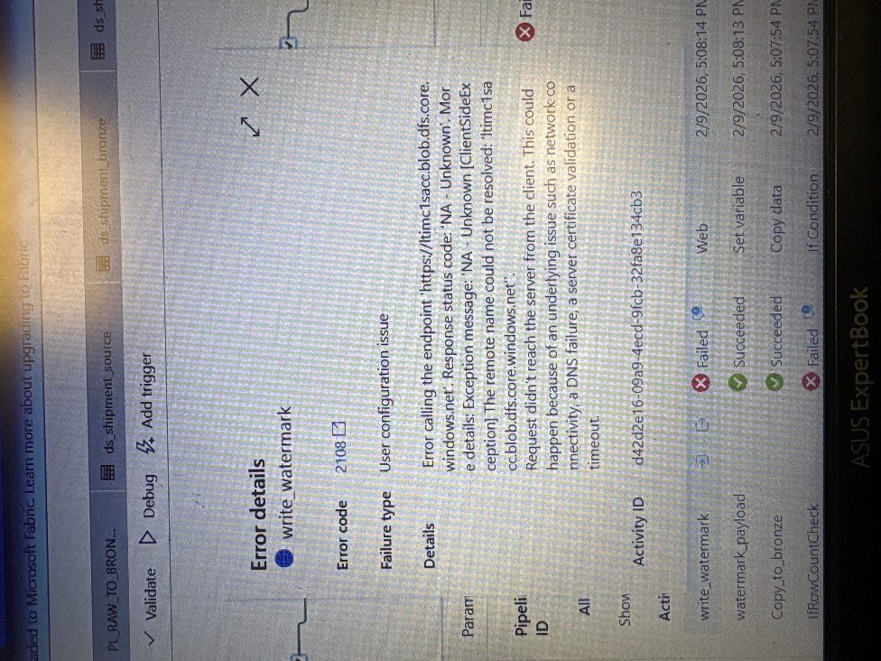
Resolved by using Blob endpoint instead.
Invalid Copy Output References
Incorrect usage of unsupported properties.
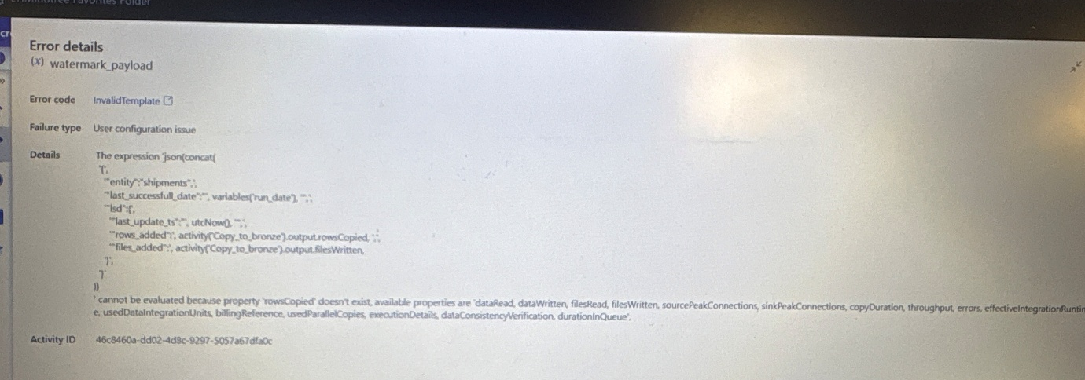
Resolved by using valid outputs such as rowsRead and filesWritten.

